Client Program Evaluation

Lauren Causby
Sport and Performance Psychology Master’s Program, University of Western States
COUN 6120: Research Methods and Program Evaluation
Dr. Gily Meir
February 6, 2022

Client Program Evaluation
Introduction
Musicians face high pressure in the pursuit of performance excellence. Sport and performance psychology methods are being applied to the community of musicians in Seattle, Washington to find how mental skills and performance counseling affects different aspects of the musician’s lives.
Sample Population
The sample population was taken from the musicians that performed through programs at Benaroya Concert Hall in Seattle, Washington. The programs include Seattle Youth Symphony Orchestra, Seattle Symphony, and other musicians that had performed at the concert hall during the time of the research. The demographics of the study are as follows:
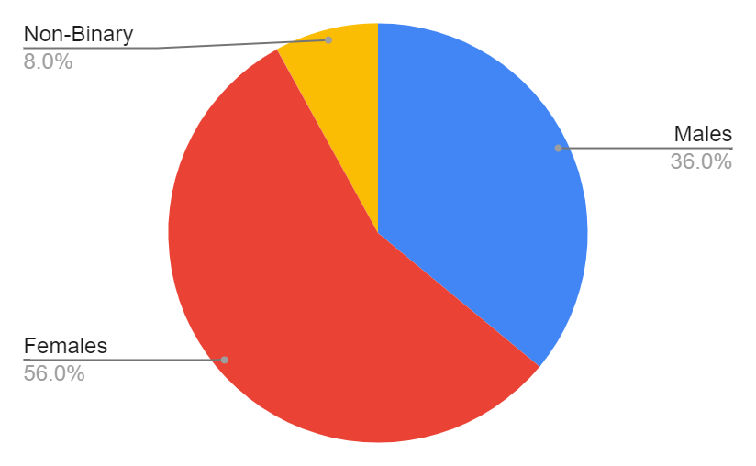
Figure 1: Sex

Figure 2: Race
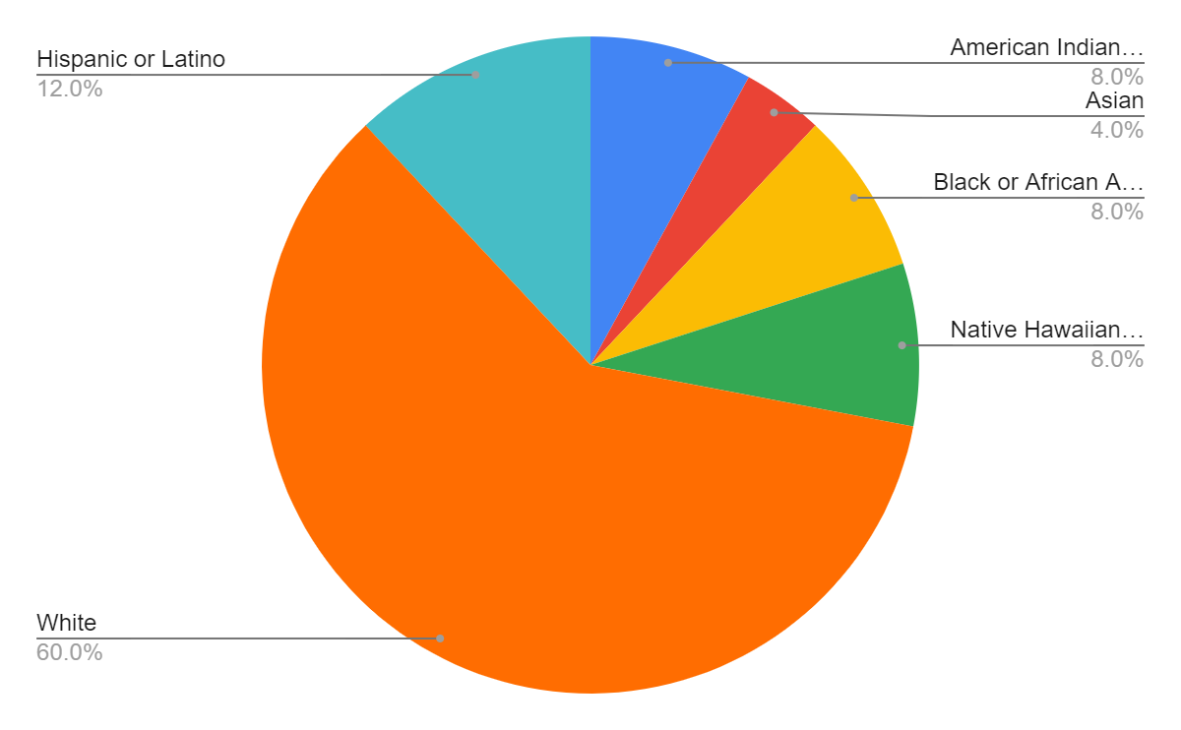

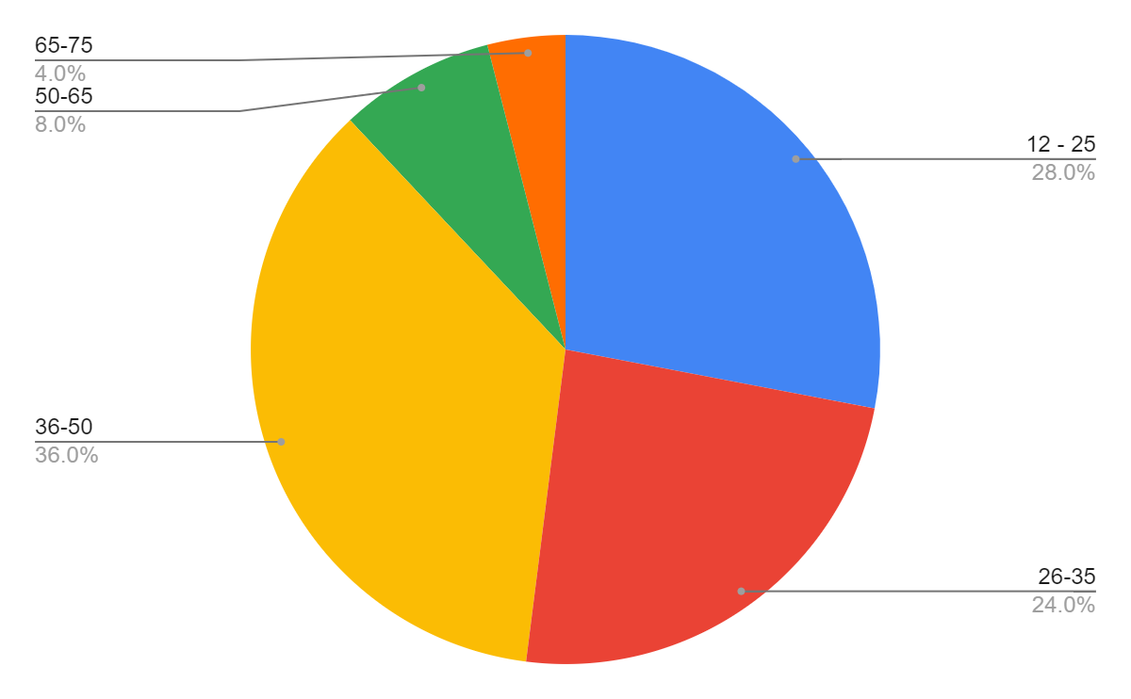
Figure 2: Age Groupings

Figure 3: Evaluative Belief Scores
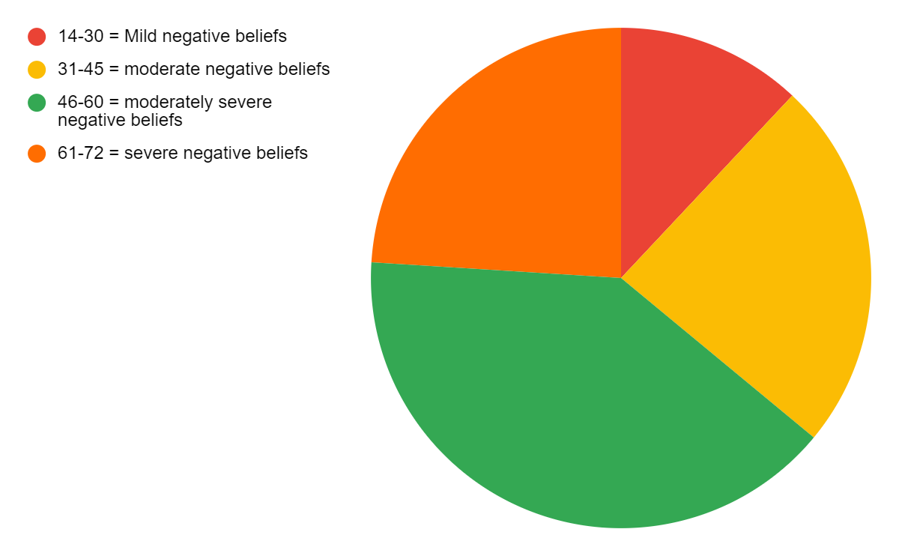

Figure 4: Athletic Coping Skills Inventory (ACSI-28)
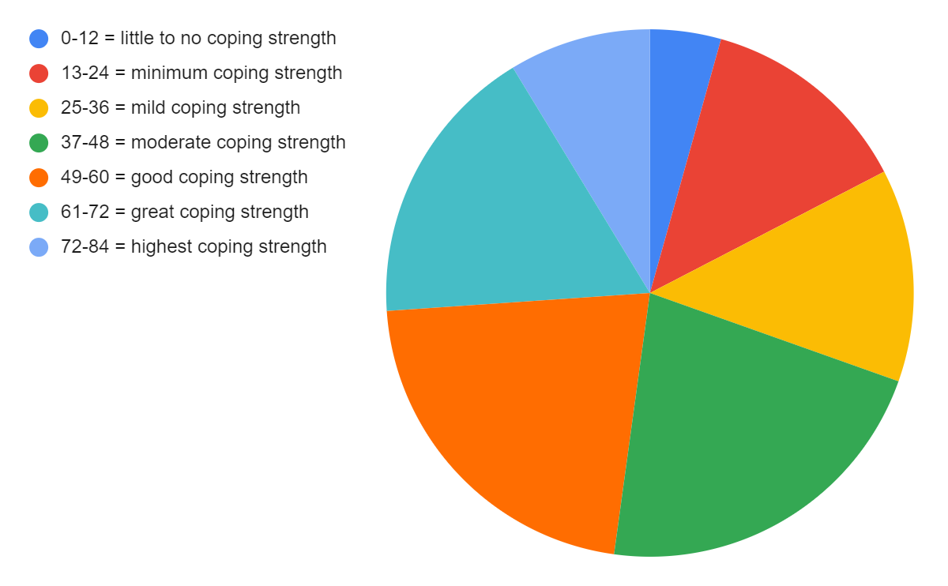

Figure 5: Counseling Session Satisfaction
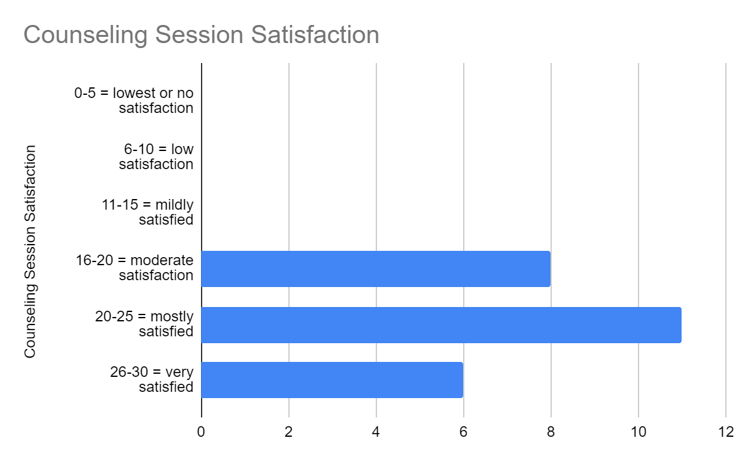

Figure 6: Inner Musician Mentality Assessment
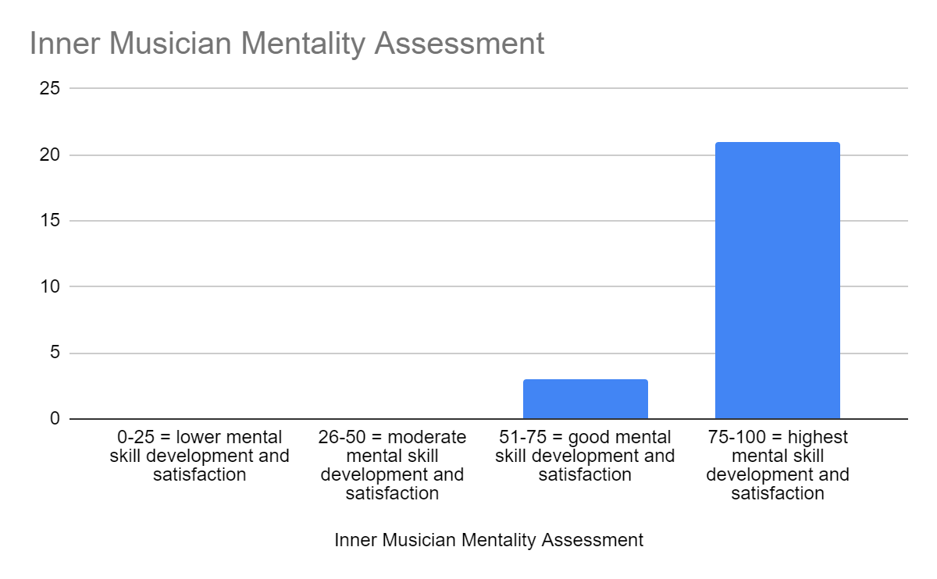
Data Analysis
The implemented program of performance and mental skills counseling for musicians showed great success and satisfaction among the sample population. The major assessment tools focused on self-esteem building, negative self-belief, and overcoming adversity.
The targeted age range was broad due to the nature of the musician community. The research question was whether or not mental skills training was effective for musicians, and this may appear differently in a great range of ages, thus was worth exploring. Overall, the relevant large age range shows that musicians from all “walks of life” are experiencing similar mental health issues and the application of counseling seems to be helpful in the longevity of their practice and participation in musical groups.
The reported sex and race of each participant could have potential to represent a mental health struggle that is rooted in underlying societal stigmas regarding their sex or race. Both sex and race have shown throughout the history of performing musicians to have an affect on success as well as potential in building a career as a professional musician. Both of these categories should be explored further, especially diving into the history of mental health within these populations.
The Evaluative Belief assessment tool measured the intensity of negative beliefs about oneself (Laois Offaly Longford Westmeath Mental Health Services, 2012). The assessment was given prior to counseling sessions beginning to discover the baseline of mental health among the participants. This assessment revealed there was a very high percent of participants that believed negatively about oneself within their lives overall, or mostly as a musician. This showed a great need for counseling to help the community overcome negative self-talk for higher success.
The Athletic Coping Skills Inventory (ACSI-28) measured several different aspects of grit, confidence, goal-setting, and more (pdf4pro.com, 2019). Musicians could see their specific scores of each subtopic, and the overall score showed the mental strength they felt they had. Most participants showed to have good coping skills mostly. Through counseling sessions, participants were taught new tools and strategies to help improve all subtopics from this assessment. There was growth in coping skills later in the study using the Inner Musician Mentality Assessment (IMMA). The IMMA was a reduced version of the ACSI-28 and focused on the satisfaction and growth from the overall program. The IMMA revealed that nearly all participants had felt an impact from counseling on their self-esteem, motivation, growth mindset, and satisfaction of the results from the counseling sessions. Generally, participants also showed good satisfaction following each session of counseling using the Counseling Session Satisfaction questionnaire.
In conclusion, there was a great need and impact of performance counseling on the community of musicians in Seattle, Washington. Participants from a large age range all seemed to reap benefits from the sessions such as strength in overcoming adversity, believing in oneself in a more positive manner, and feeling motivated to continue their journey in musical performance.

Resources

Laois Offaly Longford Westmeath Mental Health Services. (2012). Mental health assessment tools. Janssen. https://www.drugsandalcohol.ie/17625/1/MentalHealthAssessmentTools.pdf

pdf4pro.com. (2019, January 19). athletic coping skills inventory / athletic-coping-skills-inventory.pdf /. PDF4PRO. https://pdf4pro.com/view/athletic-coping-skills-inventory-552daa.html

file:///C:/Users/laure/Downloads/athletic-coping-skills-inventory-athletic-management.pdf

